Guide to Creating Your Meet Manager File

- Open Meet Manger.
- Select file, and then Open/New.
- Type in the name of the swim meet, e.g. 2017 “Club Name” SC Preparation Meet.
- Select Open to see the Meet Set-up page.
- Enter all the necessary details (as shown in image below) and select ok.
- Meet Name
- Facility Name and Details
- Important Dates
  - Start Date of Meet
  - End Date of Meet
  - Age-Up Date
  - Entry Open Date
  - Entry Deadline
- ID Format
  - AUS – Australian Swimming
- Host LSC
  - QLD
- Base Country
  - AUS
- Check the Default Touch Pads at both ends box

- Class
  - Age Group
- Meet Type
  - Standard
- Meet Style
  - Standard
- Course
  - LC (Long Course – 50m) or SC (Short Course – 25m)
- DQ Codes
  - Custom DQ Codes
- Time Adjustment Method
  - FINA rules
- Timers Connected to this computer
  - One timer
  - Timer 1 name (Pool 1)

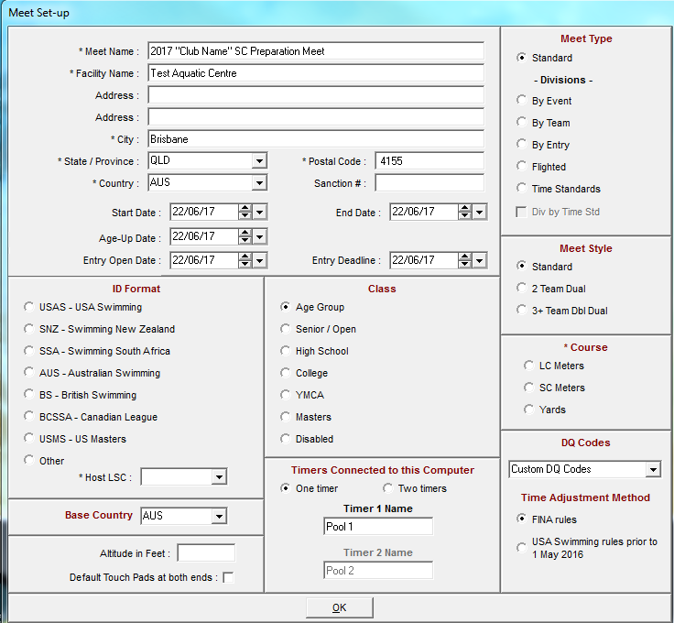
- Select the set up menu item in the top left hand corner and then select Entry/Scoring Preferences followed by Entries/Entry Limits.
  - Make sure you have the correct date in ‘Entries must have been performed on or after’. (The date is the first day, of the first month ‘The Year Before’). Example 1/01/2015.
- Input the minimum age for open events to the minimum age according to your program of events and then select ok.
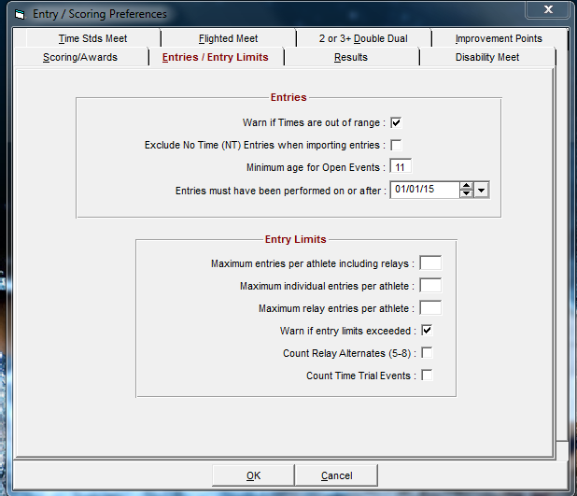
- Next select the events option from the main menu in the top left hand corner and select add to start adding your events.
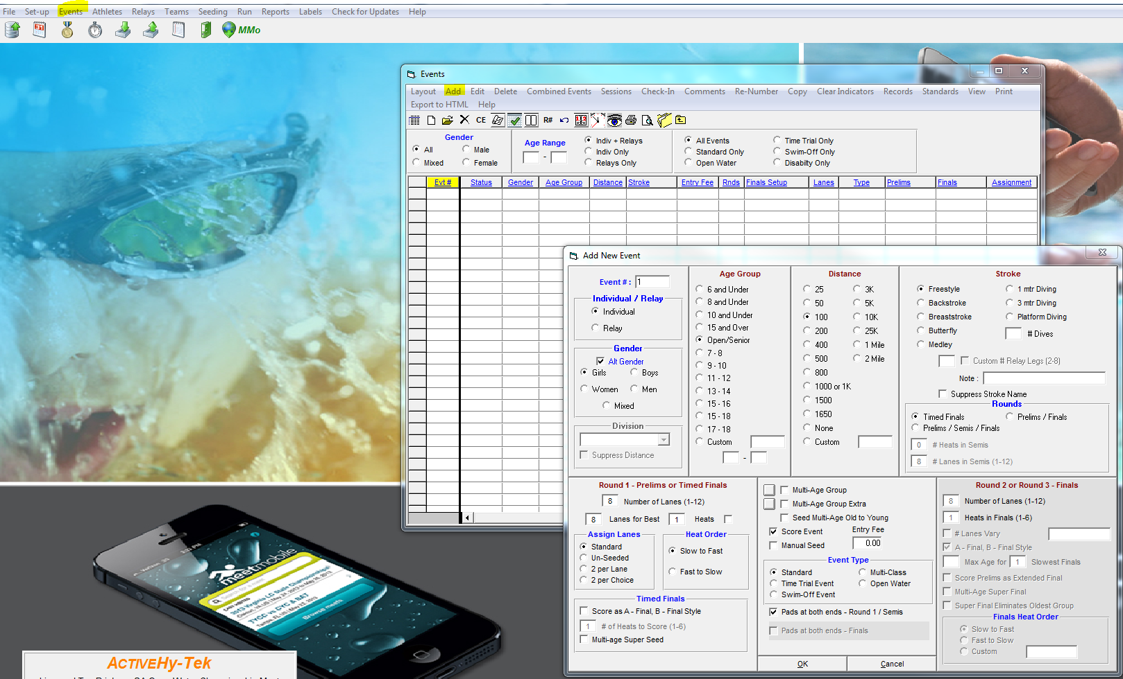
“Event #” Shows which event you are creating.
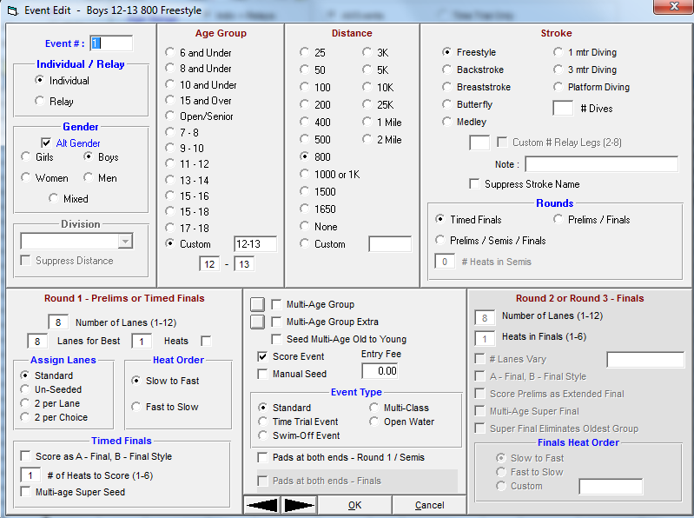

Shows whether it is an individual, or relay event.

- The Add New Event Window will allow you to create the events desired. To create your event select the gender, age, distance and stroke, and then press ok to make the first event.
- If it is a Multi-Class event you will need to select the Multi-Class option in “Event Type”
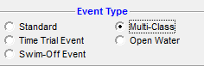
  - Multi Class events are set up as 13-99 / 10-99 etc. The lowest number should be the minimum age at the competition.

- Pay special attention to the multi aging options in the events, as this needs to be edited according to the qualifying times from your program of events.
  - When entering age groups for an event if the age group is not available from the pre-set menu use the custom option.
- If you make a mistake with one of the events, simply double click the event from the Events window to edit as desired.
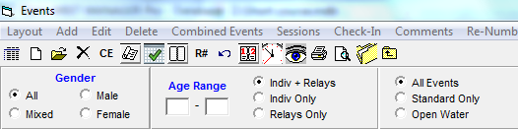
- Once you have added in all the date into the events section open up time Standards

- Click “Create Report”
- Print the report and use it to check with the program of events that it is all correct.
- When entering the Qualifying time click “Add New Record Tag”.
- Name it QT in top row and Qualifying Time in the lower Row.
- Qual with Tag to be Equal to or faster.
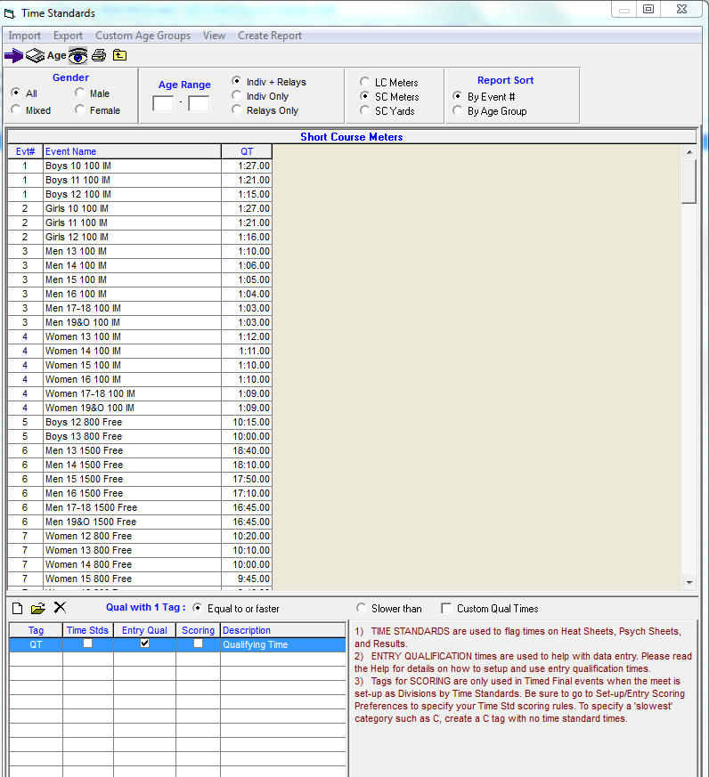
- Click ok and that will prevent you losing the QT’s when you exit the time standards page.

