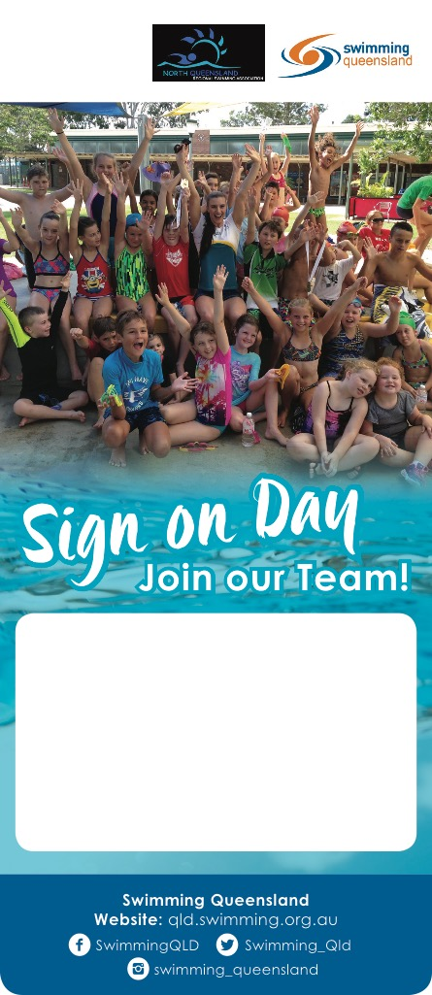

**FREE Sausage Sizzle!**

Waroona Swimming Club

184 Redback Rd, Waroona

Saturday 7th October 2017

10am – 12pm

[www.waroonaswimming.com](http://www.waroonaswimming.com/)