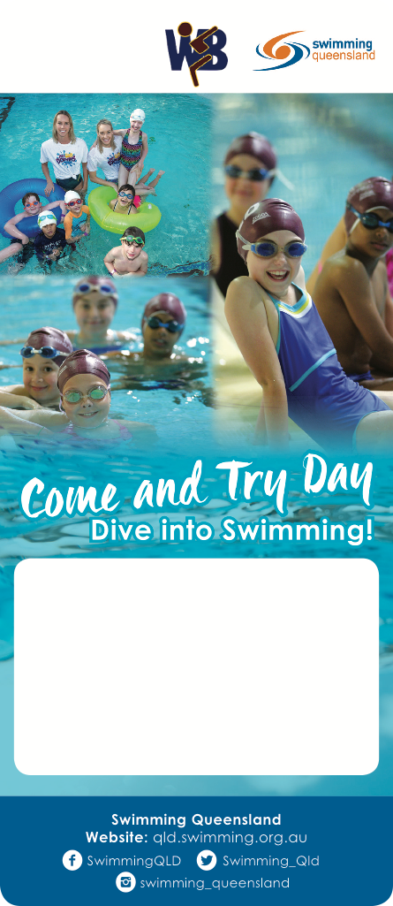

**Waroona Swimming Club**

184 Redback Rd, Waroona

Saturday 7th October 2017

10am – 12pm

Please contact Debra for more info 0412 345 678

[www.waroonaswimming.com](http://www.waroonaswimming.com/)